SILIGURI INSTITUTE OF TECHNOLOGY

Major Project: MCAN381

**Face Attendance System with Anti-Spoofing and Multiple Face Recognition**

by

Abhijeet Karmakar -33671023007

Biswajit Sarkar – 33671023013

Renu Gupta - 336710230

Under the guidance of

Dr. Tumpa Banarjee

Submitted to the Department of **Master of Computer Application** in partial fulfillment of the requirements for the award of the degree MCA**.**

**Year of Submission: 2025**



**P.O. SUKNA, SILIGURI, DIST. DARJEELING, PIN: 734009**

**Tel: (0353)2778002/04, Fax: (0353) 2778003**

**DECLARATION**

This is to certify that Report entitled “**Face Attendance System with Anti-Spoofing and Multiple Face Recognition**”

which is submitted by me in partial fulfillment of the requirement for the award of degree MCA at Siliguri Institute of Technology under Maulana Abul Kalam Azad University of Technology, West Bengal. We took the help of other materials in our dissertation which have been properly acknowledged. This report has not been submitted to any other Institute for the award of any other degree.

Date:

|  |  |  |
| --- | --- | --- |
| Student Name | Roll No | Signature |
|  |  |  |
|  |  |  |
|  |  |  |

CERTIFICATE

This is to certify that the project report entitled

submitted to Department of MCA of Siliguri Institute of Technology in partial fulfilment of the requirement for the award of the degree of MCA during the academic year 2023-25, is a bonafide record of the project work carried out by them under my guidance and supervision.

|  |  |  |
| --- | --- | --- |
| Student’s Name | Student’s Registration No | Student’s Roll No |
|  |  |  |
|  |  |  |
|  |  |  |

..............................................

**Signature of Project Guide**

# Dr. Tumpa Banarjee

**..........................................**

# Signature of the HOD Department of MCA

**Acknowledgment**

I am deeply grateful to all those who have supported me throughout the journey of this project.

First and foremost, I extend my heartfelt gratitude to Dr. Tumpa Banerjee, my project guide, for her invaluable guidance, unwavering support, and insightful suggestions at every stage of this work. Her mentorship has been a source of constant inspiration and has greatly enriched the quality of this project.

I would also like to express my sincere thanks to Mr. Mrinal Das, whose expert advice, constructive feedback, and encouragement have played a pivotal role in shaping this project to its completion. His dedication and support have been truly commendable.

A special note of appreciation goes to my team members, whose collaboration, hard work, and creative ideas made this project both enjoyable and successful. Working together with such a talented group of individuals has been an unforgettable experience.

I am also immensely thankful to my classmates and juniors, whose constant support, encouragement, and suggestions helped me navigate through challenges. Their camaraderie has been a pillar of strength throughout this journey.

Finally, I owe my success to everyone who contributed to this project directly or indirectly. Their support and encouragement have made this endeavour a memorable and fulfilling one.

Signature of all the group members with date

1.

2.

3.

**Face Attendance System with Anti-Spoofing and Multiple Face Recognition**

Table of Contents

Dr. Tumpa Banarjee 3

Signature of the HOD Department of MCA 3

List of Figures 8

Introduction 10

System Analysis 10

Identification of Need 10

Preliminary Investigation 12

Feasibility Study 14

Technical Feasibility 14

Technical feasibility examines whether the project can be implemented with the available technology, tools, and expertise. Key Considerations: 14

1. Hardware Requirements: 14

o High-Resolution Cameras: Necessary for capturing detailed facial features to ensure accurate recognition. 14

o Server Infrastructure: Cloud or on-premise servers for real-time data processing, storage, and model hosting. 14

o Edge Devices: Optional integration with IoT devices such as Raspberry Pi for edge-based processing. 14

2. Software Requirements: 14

o Programming Languages: Python for machine learning model development and backend processes. 14

o Frameworks: TensorFlow, Keras, and OpenCV for deep learning and image processing. 14

o Web Framework: Django for developing the web interface to interact with the system. 14

o Database: MySQL for secure storage of attendance data, user profiles, and logs. 14

3. Technological Features: 14

o Face Recognition Algorithms: Utilize CNN-based deep learning models for real-time face recognition and feature extraction. 14

o Liveness Detection: Implement anti-spoofing techniques to detect fake faces using images, videos, or masks. 14

o Integration: Seamlessly connect cameras, software modules, and databases into a cohesive system. 14

4. Development Tools: 14

o Python IDEs (e.g., PyCharm, Jupyter Notebook, Spyder). 14

o Camera access tools (e.g., OpenCV, TensorFlow and imutils libraries). 15

o Cloud services for hosting and scaling (e.g., AWS, Azure, or Google Cloud). 15

Operational Feasibility 15

Operational feasibility ensures that the system is practical and can be used effectively in real-world scenarios. 15

Key Considerations: 15

1. Ease of Use: 15

o A user-friendly interface designed with HTML, CSS, and Django makes the system accessible for both technical and non-technical users. 15

o Automated features like in-time, out-time, and working hour calculation simplify operations for HR staff and administrators. 15

2. Applicability Across Industries: 15

o Suitable for educational institutions, offices, factories, and healthcare facilities to streamline attendance tracking. 15

o Supports multi-face recognition, making it ideal for scenarios where large groups gather simultaneously. 15

3. Accuracy and Reliability: 15

o High accuracy is ensured through advanced algorithms and robust training datasets for face recognition and liveness detection. 15

o The system's scalability allows it to handle environments with varying numbers of users and attendance points. 15

4. Data Privacy and Security: 15

o User data is encrypted and securely stored in a database, complying with data protection standards. 15

o Role-based access control ensures that only authorized personnel can view or edit sensitive attendance data. 15

Economic Feasibility 15

Economic feasibility evaluates the cost of development, deployment, and maintenance against the expected benefits of the system. 15

Key Considerations: 15

1. Development Costs: 15

o Software Development: Costs associated with developers, data scientists, and designers for building and testing the system. 15

o Hardware: Expenses for cameras, servers, or optional IoT devices like Raspberry Pi. 15

o Training: Cost of training administrators and users to use the system effectively. 15

2. Operational Costs: 15

o Hosting and Maintenance: Hosting the web application on cloud platforms (e.g., AWS, Azure) incurs ongoing costs. 15

o Updates and Support: Periodic updates to improve algorithms and enhance system performance. 15

3. Cost Savings: 15

o Time Savings: Automation reduces the time spent on manual attendance tracking and report generation. 15

o Resource Savings: Eliminates the need for physical attendance registers, ID cards, or manual intervention. 15

o Fraud Prevention: Reduces losses caused by proxy attendance or fraudulent practices. 15

4. Benefit-Cost Analysis: 15

o The initial development and deployment costs are offset by long-term savings in administrative overhead, increased accuracy, and improved employee productivity. 15

Legal Feasibility 16

Legal feasibility ensures that the system complies with data protection laws and regulations. 16

Key Considerations: 16

1. Data Protection: 16

o User data (e.g., facial images, attendance logs) will be stored securely with encryption. 16

o The system will comply with privacy regulations such as GDPR (General Data Protection Regulation) and other applicable laws. 16

2. User Consent: 16

o Employees or students will be required to provide informed consent for their data to be captured and used. 16

Feasibility Challenges 16

• Hardware Costs: High-resolution cameras and servers may increase initial costs for smaller organizations. 16

• Liveness Detection Accuracy: Advanced spoofing methods (e.g., deepfakes) require continuous improvements to detection algorithms. 16

• Internet Dependency: The system relies on stable network connections for real-time attendance logging and data storage. 16

Project Planning 16

1. Introduction 16

2. Project Objectives 16

3. Deliverables 17

4. Scope of Work 17

5. Project Milestones 17

6. Resources Required 17

7. Risk Management 18

8. Project Scheduling 18

9. Budget and Cost Estimation 18

10. Monitoring and Evaluation 18

Project Objectives 19

Deliverables 19

Resources Required 19

Project Scheduling 20

Software Requirement Specifications (SRS) 20

Software Engineering Paradigm Applied 20

Data Model, Control Flow Diagrams, and State Diagrams 21

System Design 21

System design is a critical phase in the development of the Face Attendance System with Anti-Spoofing and Multiple Face Recognition. This chapter outlines the modularization of the system, data integrity and constraints, database design, procedural and object-oriented design, and user interface design. 21

Modularization Details 21

Database Design / Procedural Design / Object-Oriented Design 23

User Interface Design 24

Coding 26

Complete Project Coding is not required. Include important modules' codes only. 29

Testing 31

A. TESTING TECHNIQUES USED 31

B. TESTING STRATEGIES 31

White Box Testing 31

Debugging and Code improvement 31

Database/data security 31

Creation of User profiles and access rights 31

Cost Estimation of the Project 31

Reports (sample layouts should be placed) PERT Chart, Gantt chart 31

Conclusion and Recommendations 31

Referencing and Appendices 32

# List of Figures

Page 16 System planning and working figure

Page 25-30 Code screenshots of face detection and anti-spoofing detection.

**Abstract**:

In modern times, facial recognition technology has emerged with a secure and efficient means of authentication and identification with high resolution camera. Traditional attendance systems, such as manual registers and ID card-based systems, often face issues like inefficiency, proxy attendance, and forgery. Biometric is the prevalent for attendance system and security industry. Of late, many biometric system is used for identification like face recognition, retinal, iris scanning, fingerprint recognition etc.

The proposed system employs biometric identification, focusing on face recognition due to its user-friendly nature and speed. A critical aspect of this system is liveness detection, which distinguishes between genuine faces and spoofing attempts using photographs, videos, or masks. By leveraging computer vision and deep learning techniques, specifically Convolutional Neural Networks (CNNs), the system effectively addresses the challenges associated with liveness detection and face recognition.

The system is designed to automatically record attendance, capturing in-time, out-time, and calculating working days and hours on a daily and monthly basis. Human resource personnel can utilize this data to manage employee leave records, including total leave allotted, leave taken, and types of leave applied for. The system also incorporates a leave approval hierarchy to streamline the process.

Key technologies employed in this project include Python libraries such as TensorFlow, Keras, OpenCV, and SQLite3 or MySQL for data storage and retrieval and Django use for maintaining the full application. The user interface is developed as a web application, ensuring accessibility and ease of use for administrators and employees alike.

# Introduction

In modern times, facial recognition technology has emerged with a secure and efficient means of authentication and identification with high resolution camera. Traditional attendance systems, such as manual registers and ID card-based systems, often face issues like inefficiency, proxy attendance, and forgery. Biometric is the prevalent for attendance system and security industry. Of late, many biometric system is used for identification like face recognition, retinal, iris scanning, fingerprint recognition etc. Face recognition is most accepted system for identification and anti-spoofing as it is convenient, user friendly, fast and avoid physical contact. Face recognition attendance not only emphasize recognition of face also include mechanism to differentiate between the live face or face from videos, images, and face mask. Therefor liveness detection is a major challenge for any face recognition system.

Our objective is to develop an attendance system that can be used by any institute or organization for marking attendance of the system. Liveness detection is also taken consideration to defend any type of spoofing. This system will record attendance of the candidate with in-time, out-time, and working day and working hour per day/month will be calculated automatically. Human resource personal will leverage this system for calculating total number of leave allotted, leave taken by the employee and type of leave employee have applied or taken. The system will also try to maintain the leave approval hierarchy of the employee.

Liveness detection and face recognition problem can be solved using computer vision with deep learning techniques. We will build a CNN based model along with the feature extraction to solve this issue and web application will be developed as user interface.

# System Analysis

# Identification of Need

In today's fast-paced and technology-driven world, traditional methods of tracking attendance, such as manual registers or ID card-based systems, have become outdated and prone to inefficiencies. The need for a robust, secure, and automated attendance system has become evident, particularly in educational institutions, corporate environments, and industries. Below are the key reasons why a multi-face recognition anti-spoofing attendance system is necessary:

**1. Eliminating Inefficiencies in Attendance Tracking**

* Traditional systems are time-consuming and prone to human errors.
* Manual processes increase the workload on administrative staff and often lead to inaccurate attendance records.
* Proxy attendance or "buddy punching" (using someone else's ID card or manually signing on behalf of others) is a common malpractice that undermines the integrity of attendance tracking.

**2. Enhanced Security and Anti-Spoofing**

* Conventional biometric systems, such as fingerprint scanners or card-based systems, are vulnerable to spoofing and forgery.
* Advanced face recognition with anti-spoofing technology can detect attempts to deceive the system, such as using photographs, videos, or face masks. This ensures that only live and authenticated individuals are marked present.

**3. Convenience and User-Friendly Features**

* Face recognition systems are contactless, making them more hygienic and suitable for environments where physical contact should be minimized (e.g., during a pandemic).
* The process is quick, seamless, and user-friendly, ensuring minimal disruption to workflows.

**4. Scalability and Multi-Face Recognition**

* A system capable of recognizing multiple faces simultaneously is ideal for scenarios where large groups of people need to mark their attendance at the same time (e.g., classrooms, shift changes in factories, etc.).
* This significantly reduces the time taken for attendance logging compared to one-by-one recognition methods.

**5. Automated Attendance Management and Reporting**

* The system can automatically record and manage attendance, reducing manual intervention.
* Features such as in-time, out-time, total working hours, and leave management can be seamlessly integrated into the system.
* Organizations can generate detailed reports for performance reviews, payroll management, and compliance with attendance policies.

**6. Adaptability Across Industries**

* The system is suitable for a wide range of applications, including schools, universities, offices, factories, and healthcare facilities.
* It can be integrated with existing systems to streamline attendance tracking and HR processes.

**7. Addressing Modern Challenges**

* With advancements in AI and deep learning, sophisticated spoofing attempts (e.g., high-resolution videos or deepfakes) have become a challenge. Liveness detection integrated with deep learning ensures a high level of security and reliability.
* The system also adapts to challenges like poor lighting conditions, varying camera angles, and crowded environments, ensuring accurate recognition.

**8. Resource Optimization**

* By automating attendance tracking, organizations can save time, reduce costs, and reallocate resources to more critical tasks.
* Administrative workloads are reduced, as attendance data is automatically logged and stored in secure databases for easy retrieval.

**9. Future-Proofing with Technology**

* A multi-face recognition anti-spoofing system is a step toward embracing cutting-edge technology in day-to-day operations.
* It aligns with the growing need for digital transformation and automation in workplaces and institutions.

# Preliminary Investigation

The preliminary investigation is the initial step to understand the purpose, feasibility, and requirements of the Face Attendance System with Anti-Spoofing and Multiple Face Recognition. This phase identifies the problems with existing systems, evaluates the benefits of the proposed solution, and lays the groundwork for its development.

**1. Problem Statement**

The existing attendance systems, including manual registers, ID card-based methods, or basic biometric systems like fingerprint recognition, face several challenges:

* **Inefficiency**: Manual attendance tracking is time-consuming and prone to human error.
* **Proxy Attendance**: In traditional systems, it is easy to commit attendance fraud, such as buddy punching or using fake IDs.
* **Security Gaps**: Many biometric systems lack robust anti-spoofing mechanisms, making them vulnerable to manipulation via photos, videos, or face masks.
* **Scalability Issues**: Single-person recognition systems cannot efficiently handle large groups, especially in organizations or educational institutions with hundreds or thousands of attendees.

**2. Objectives of the Investigation**

The preliminary investigation aims to:

* Identify the limitations of existing attendance systems.
* Understand the requirements for an advanced system that integrates multi-face recognition and anti-spoofing features.
* Assess the technical, operational, and financial feasibility of the proposed system.
* Define the scope and deliverables of the project.

**3. Proposed System Features**

The proposed system addresses the problems of existing methods and incorporates the following features:

1. **Multi-Face Recognition**: Simultaneous recognition of multiple faces in crowded settings such as classrooms, offices, or industrial units.
2. **Anti-Spoofing Mechanisms**: Liveness detection to differentiate between real faces and spoofing attempts using images, videos, or masks.
3. **Automation and Efficiency**: Automated attendance logging, calculation of working hours, and leave tracking for individuals.
4. **Scalability and Flexibility**: Compatibility with various industries and organizations, adaptable to different scales of operation.
5. **User-Friendly Interface**: A web-based application for easy access and management of attendance data by both employees and administrators.
6. **Data Security**: Secure storage and encryption of sensitive user data in the database.

**4. Investigation Steps**

1. **Requirement Gathering**
   * **User Requirements**: Consult stakeholders, including HR personnel, administrators, and end-users, to identify their expectations.
   * **Technical Requirements**: Define hardware and software specifications, including cameras, servers, frameworks (e.g., TensorFlow, Django), and databases (e.g., MySQL).
   * **Environmental Constraints**: Assess lighting, camera angles, and internet connectivity in deployment locations.
2. **Existing System Analysis**
   * Evaluate current attendance systems to identify inefficiencies and areas for improvement.
   * Study the effectiveness of existing biometric systems and their vulnerabilities to spoofing attempts.
3. **Data Collection**
   * Collect sample datasets, including real and spoofed face images and videos, to train and test the system's models.
   * Identify publicly available datasets for face recognition and liveness detection.
4. **Risk Assessment**
   * Identify risks such as low recognition accuracy, hardware failures, and vulnerability to advanced spoofing techniques (e.g., deepfakes).
   * Define strategies to mitigate risks, such as regular model updates, training on diverse datasets, and incorporating advanced algorithms.

**5. Benefits of the Proposed System**

* **Improved Accuracy**: High recognition accuracy with anti-spoofing mechanisms ensures reliability.
* **Time and Cost Efficiency**: Automation reduces administrative effort and time spent on attendance tracking.
* **Enhanced Security**: Liveness detection and data encryption safeguard the system from fraud and data breaches.
* **Scalability**: The system is designed to handle large-scale deployments, suitable for various organizational needs.

**6. Output of Preliminary Investigation**

Based on the findings, the preliminary investigation concludes that:

* There is a significant need for a secure and scalable face recognition attendance system.
* The proposed system is technically and operationally feasible with available tools and technologies.
* The system can achieve high accuracy and efficiency with proper development, testing, and deployment.

# Feasibility Study

# Technical Feasibility

# Technical feasibility examines whether the project can be implemented with the available technology, tools, and expertise. Key Considerations:

# Hardware Requirements:

# High-Resolution Cameras: Necessary for capturing detailed facial features to ensure accurate recognition.

# Server Infrastructure: Cloud or on-premise servers for real-time data processing, storage, and model hosting.

# Edge Devices: Optional integration with IoT devices such as Raspberry Pi for edge-based processing.

# Software Requirements:

# Programming Languages: Python for machine learning model development and backend processes.

# Frameworks: TensorFlow, Keras, and OpenCV for deep learning and image processing.

# Web Framework: Django for developing the web interface to interact with the system.

# Database: MySQL for secure storage of attendance data, user profiles, and logs.

# Technological Features:

# Face Recognition Algorithms: Utilize CNN-based deep learning models for real-time face recognition and feature extraction.

# Liveness Detection: Implement anti-spoofing techniques to detect fake faces using images, videos, or masks.

# Integration: Seamlessly connect cameras, software modules, and databases into a cohesive system.

# Development Tools:

# Python IDEs (e.g., PyCharm, Jupyter Notebook, Spyder).

# Camera access tools (e.g., OpenCV, TensorFlow and imutils libraries).

# Cloud services for hosting and scaling (e.g., AWS, Azure, or Google Cloud).

# Operational Feasibility

# Operational feasibility ensures that the system is practical and can be used effectively in real-world scenarios.

# Key Considerations:

# Ease of Use:

# A user-friendly interface designed with HTML, CSS, and Django makes the system accessible for both technical and non-technical users.

# Automated features like in-time, out-time, and working hour calculation simplify operations for HR staff and administrators.

# Applicability Across Industries:

# Suitable for educational institutions, offices, factories, and healthcare facilities to streamline attendance tracking.

# Supports multi-face recognition, making it ideal for scenarios where large groups gather simultaneously.

# Accuracy and Reliability:

# High accuracy is ensured through advanced algorithms and robust training datasets for face recognition and liveness detection.

# The system's scalability allows it to handle environments with varying numbers of users and attendance points.

# Data Privacy and Security:

# User data is encrypted and securely stored in a database, complying with data protection standards.

# Role-based access control ensures that only authorized personnel can view or edit sensitive attendance data.

# Economic Feasibility

# Economic feasibility evaluates the cost of development, deployment, and maintenance against the expected benefits of the system.

# Key Considerations:

# Development Costs:

# Software Development: Costs associated with developers, data scientists, and designers for building and testing the system.

# Hardware: Expenses for cameras, servers, or optional IoT devices like Raspberry Pi.

# Training: Cost of training administrators and users to use the system effectively.

# Operational Costs:

# Hosting and Maintenance: Hosting the web application on cloud platforms (e.g., AWS, Azure) incurs ongoing costs.

# Updates and Support: Periodic updates to improve algorithms and enhance system performance.

# Cost Savings:

# Time Savings: Automation reduces the time spent on manual attendance tracking and report generation.

# Resource Savings: Eliminates the need for physical attendance registers, ID cards, or manual intervention.

# Fraud Prevention: Reduces losses caused by proxy attendance or fraudulent practices.

# Benefit-Cost Analysis:

# The initial development and deployment costs are offset by long-term savings in administrative overhead, increased accuracy, and improved employee productivity.

# Legal Feasibility

# Legal feasibility ensures that the system complies with data protection laws and regulations.

# Key Considerations:

# Data Protection:

# User data (e.g., facial images, attendance logs) will be stored securely with encryption.

# The system will comply with privacy regulations such as GDPR (General Data Protection Regulation) and other applicable laws.

# User Consent:

# Employees or students will be required to provide informed consent for their data to be captured and used.

# Feasibility Challenges

# Hardware Costs: High-resolution cameras and servers may increase initial costs for smaller organizations.

# Liveness Detection Accuracy: Advanced spoofing methods (e.g., deepfakes) require continuous improvements to detection algorithms.

# Internet Dependency: The system relies on stable network connections for real-time attendance logging and data storage.

# Project Planning

# 1. Introduction

The project planning phase outlines the timeline, milestones, resources, and tasks required to develop the Face Attendance System with Anti-Spoofing and Multiple Face Recognition. It ensures systematic progress toward the project's objectives while managing resources efficiently.

# 2. Project Objectives

Primary Objective: To develop a reliable and efficient attendance management system using face recognition and anti-spoofing mechanisms.

Specific Objectives:

Implement a robust liveness detection model to prevent fraudulent attendance using fake faces.

Automate attendance tracking, including in-time, out-time, and work hours calculation.

Design a scalable system with a user-friendly interface for seamless integration into various institutions.

Ensure data security and privacy with encrypted storage and controlled access.

# 3. Deliverables

System Deliverables:

A fully functional face recognition-based attendance system.

Integrated liveness detection to prevent spoofing attempts.

Automated attendance reports with in-time, out-time, work hours, and leave management.

Documentation Deliverables:

User manuals and training guides for administrators and end users.

Project documentation, including technical design, feasibility study, and testing reports.

# 4. Scope of Work

The project involves the development of:

Core Functionalities:

Face detection and recognition system.

Liveness detection algorithms to identify real vs. fake faces.

Attendance logging and leave management functionalities.

Interface:

A web-based user interface for administrators and employees to access attendance details.

Data Management:

Secure storage of user data, attendance records, and logs using MySQL.

# 5. Project Milestones

The following milestones will guide the project timeline:

Requirement Analysis (Week 1–2):

Gather system requirements from stakeholders.

Identify hardware and software tools needed.

System Design (Week 3–4):

Create architectural diagrams (e.g., ERD, flowcharts, and state diagrams).

Design database structure and system modules.

Data Collection and Preprocessing (Week 5–6):

Collect real and fake face datasets for training the liveness detection model.

Label and preprocess images/videos for training.

Model Development (Week 7–10):

Train CNN models for face recognition and liveness detection using TensorFlow and Keras.

Evaluate model performance using validation and testing datasets.

System Integration (Week 11–12):

Integrate the trained model with Django for backend processing.

Develop the web interface for user interaction.

Testing and Debugging (Week 13–14):

Perform unit testing, integration testing, and user acceptance testing (UAT).

Fix any issues identified during testing.

Deployment and Documentation (Week 15–16):

Deploy the system on a local server or cloud platform.

Provide user documentation and training materials.

# 6. Resources Required

Human Resources

Team Members:

1 Project Manager: Oversees project planning and execution.

2 Software Developers: Implement face recognition algorithms and develop the web interface.

1 Data Scientist: Builds and trains machine learning models.

1 UI/UX Designer: Designs a user-friendly interface.

Technical Resources

Hardware:

High-resolution camera for capturing facial features.

Laptops/PCs with GPUs for model training.

Cloud servers (AWS, Azure, or Google Cloud) for hosting the system.

Software and Tools:

Python, TensorFlow, and Keras for deep learning.

OpenCV for image and video processing.

Django for web application development.

MySQL for database management.

# 7. Risk Management

Identified Risks:

Technical Risks:

Inaccurate face recognition in poor lighting conditions.

Failure of liveness detection against advanced spoofing techniques (e.g., deepfakes).

Operational Risks:

Users not adapting to the new system quickly.

Internet connectivity issues affecting real-time data processing.

Economic Risks:

Unexpected costs for hardware or cloud hosting.

Mitigation Strategies:

Use high-resolution cameras and image enhancement techniques to improve recognition accuracy.

Continuously update and train the liveness detection model with new datasets.

Allocate additional funds to address unforeseen expenses.

Provide comprehensive user training and support during the deployment phase.

# 8. Project Scheduling

A Gantt Chart will be used to track project progress. Below is an overview of the timeline:

| Task | Duration | Start Date | End Date |
| --- | --- | --- | --- |
| Requirement Analysis | 2 Weeks | Week 1 | Week 2 |
| System Design | 2 Weeks | Week 3 | Week 4 |
| Data Collection and Preprocessing | 2 Weeks | Week 5 | Week 6 |
| Model Development | 4 Weeks | Week 7 | Week 10 |
| System Integration | 2 Weeks | Week 11 | Week 12 |
| Testing and Debugging | 2 Weeks | Week 13 | Week 14 |
| Deployment and Documentation | 2 Weeks | Week 15 | Week 16 |

# 9. Budget and Cost Estimation

The budget is divided into development, testing, deployment, and training costs.

| Category | Estimated Cost (USD) |
| --- | --- |
| Hardware (Cameras, Servers) | $2,000 |
| Software and Tools | $500 |
| Development Team Salaries | $5,000 |
| Cloud Hosting | $1,000 |
| Training and Documentation | $500 |
| Total | $9,000 |

# 10. Monitoring and Evaluation

Progress Tracking: Weekly status meetings to review tasks completed, pending, or delayed.

Performance Metrics:

Model accuracy for face recognition and liveness detection.

System responsiveness and user satisfaction.

Evaluation:

Conduct user acceptance testing (UAT) to ensure the system meets requirements.

Collect feedback for future enhancements.

# Project Objectives

This project aims to design and implement an advanced attendance management system that leverages face recognition and liveness detection techniques to ensure secure and efficient attendance tracking.

1. Reliability and Efficiency
   * To develop a reliable attendance system that eliminates manual errors and fraudulent activities such as proxy attendance.
   * Implement real-time facial recognition and liveness detection to ensure the system operates accurately in different environmental conditions.
2. User-Friendly Interface
   * Ensure the system is intuitive, accessible, and adaptable for administrators, employees, and other stakeholders.
   * Provide a seamless experience for both technical and non-technical users.
3. Anti-Spoofing Mechanisms
   * Incorporate robust anti-spoofing measures to differentiate live faces from fraudulent inputs like photos, masks, or deepfake videos.
4. Automation and Reporting
   * Automate attendance tracking, calculation of in-time, out-time, and work hours.
   * Provide detailed attendance reports, including leave summaries, for employees and administrators.
5. Data Security and Privacy
   * Ensure secure storage of sensitive user data through encryption techniques and access control mechanisms.
   * Comply with data protection laws and organizational security policies.

# Deliverables

System Deliverables

* A fully functional Face Attendance System that includes:
  + Facial recognition with high accuracy.
  + Integrated liveness detection to combat spoofing.
  + Automated attendance logging with features for time tracking and leave management.
  + An easy-to-navigate web application with role-based access control.

Documentation Deliverables

* Comprehensive project documentation, including:
  + Requirement analysis, system design, and implementation details.
  + User manuals for system operation.
  + Training materials for administrators and users.

# Resources Required

Human Resources

1. Project Manager: Oversees the entire project lifecycle and ensures timely delivery.
2. Software Developers: Build and integrate core functionalities such as facial recognition, liveness detection, and database management.
3. Data Scientists: Develop machine learning models for face recognition and anti-spoofing.
4. UI/UX Designers: Design a user-friendly interface for both desktop and mobile platforms.
5. System Testers: Perform rigorous testing to ensure the system meets quality standards.

Technical Resources

1. Hardware:
   * High-resolution cameras (e.g., webcams, smartphone cameras) for face capture.
   * Computers with GPUs for training and running deep learning models.
   * Cloud servers (e.g., AWS, Azure, or Google Cloud) for deployment and scalability.
2. Software:
   * Python for building machine learning models.
   * TensorFlow and Keras for deep learning.
   * OpenCV for real-time image processing.
   * Django framework for web application development.
   * MySQL for database management.

# Project Scheduling

The project will be executed in multiple phases with specific deliverables at the end of each phase:

1. Phase 1: Data Collection and Preprocessing (Weeks 1–2)
   * Collect a comprehensive dataset, including real and fake face videos/images.
   * Label and preprocess the dataset for training the model.
2. Phase 2: Model Development (Weeks 3–6)
   * Train a Convolutional Neural Network (CNN) model for face recognition and anti-spoofing using TensorFlow/Keras.
   * Evaluate and fine-tune the model to achieve high accuracy and reliability.
3. Phase 3: System Integration (Weeks 7–8)
   * Integrate the trained model with a Django-based web application.
   * Design and implement modules for face detection, attendance logging, and leave management.
4. Phase 4: Testing and Debugging (Weeks 9–10)
   * Perform unit testing for individual modules and integration testing for the overall system.
   * Debug and optimize the code to improve performance and user experience.
5. Phase 5: Deployment and Documentation (Weeks 11–12)
   * Deploy the system on a cloud platform or local server.
   * Create user manuals, technical documentation, and training guides.

# Software Requirement Specifications (SRS)

System Overview

The system is designed to automate attendance tracking and eliminate fraud using advanced face recognition and anti-spoofing techniques. It ensures accuracy, security, and accessibility for all users.

Functional Requirements

1. Face Recognition: Identify individuals from a video stream using facial features.
2. Liveness Detection: Differentiate live faces from spoofing attempts.
3. Attendance Management: Record in-time, out-time, and working hours automatically.
4. Leave Management: Track leaves taken and available balances.
5. User Roles: Different access levels for administrators, HR personnel, and employees.

Non-Functional Requirements

1. Scalability: The system should handle multiple users and faces simultaneously.
2. Performance: Real-time face recognition with minimal latency.
3. Security: Data encryption and role-based access control.

# Software Engineering Paradigm Applied

The Spiral Model has been chosen for this project to allow iterative development and frequent testing at each phase. This approach ensures that risks are minimized, and feedback is incorporated throughout the development lifecycle.

1. Planning: Define objectives, scope, and constraints.
2. Risk Analysis: Identify technical and operational risks and plan mitigation strategies.
3. Engineering: Build prototypes and progressively refine the system.
4. Evaluation: Validate each phase with stakeholders before proceeding to the next.

# Data Model, Control Flow Diagrams, and State Diagrams

Data Model

The data model defines key entities and their attributes:

1. User Table:
   * Fields: user_id , name, photo.
2. Attendance Table:
   * Fields: user_id (FK), date, in_time, out_time.

Control Flow Diagram

1. User Registration:
   * Input user details and store them in the database.
   * Associate a face profile with each user.
2. Face Recognition Process:
   * Capture video feed → Extract features → Compare with stored profiles → Log attendance.

State Diagram

1. User States:
   * Registered → Can log in.
   * Logged In → Active user session.
   * Logged Out → Inactive session.
2. Attendance States:
   * Present → Marked upon successful recognition.
   * Absent → No face detected for the day.
   * Leave → Approved leave status.

# System Design

# System design is a critical phase in the development of the Face Attendance System with Anti-Spoofing and Multiple Face Recognition. This chapter outlines the modularization of the system, data integrity and constraints, database design, procedural and object-oriented design, and user interface design.

# Modularization Details

Modularization is a key aspect of the system design that divides the project into smaller, functional units to improve maintainability, scalability, and reusability. Below are the main modules and their responsibilities:

**1. User Management Module**

* **Responsibilities**:
  + User registration, profile creation, and authentication.
  + Updating user details (e.g., photo, name, contact information).
* **Key Features**:
  + User authentication via secure login mechanisms.

**2. Face Recognition Module**

* **Responsibilities**:
  + Capturing real-time facial images and processing them for recognition.
  + Performing image preprocessing (e.g., resizing, normalization).
  + Extracting unique features from facial images and matching them with stored profiles in the database.
* **Key Features**:
  + Fast and accurate face matching using a machine learning model.
  + Handling multiple face detection in group scenarios.

**3. Liveness Detection Module**

* **Responsibilities**:
  + Differentiating between live faces and spoofing attempts (e.g., photos, videos, masks).
  + Implementing anti-spoofing algorithms like motion analysis, blinking detection, or depth estimation.
* **Key Features**:
  + Real-time detection of spoofing attempts.
  + Integration with face recognition to ensure system security.

**4. Attendance Management Module**

* **Responsibilities**:
  + Logging attendance records, including check-in and check-out times.
  + Calculating total hours worked, overtime, and leave balance.
  + Generating attendance reports for employees and administrators.
* **Key Features**:
  + Automated attendance marking based on face recognition.
  + Attendance data storage in a centralized database for easy retrieval.

**Data Integrity and Constraints**

Data integrity ensures the accuracy, consistency, and reliability of the data stored and processed in the system. The system enforces integrity using constraints and validation mechanisms.

**A. Data Integrity Measures**

1. **Entity Integrity**:
   * Every table in the database must have a primary key that uniquely identifies each record. For example:
     + user_id in the User Table.
     + attendance_id in the Attendance Table.
2. **Referential Integrity**:
   * Foreign keys establish relationships between tables and maintain consistency. For instance:
     + user_id in the Attendance Table refers to the user_id in the User Table.
3. **Domain Integrity**:
   * Constraints are applied to ensure data validity within a column. Examples:
     + in_time and out_time fields in the Attendance Table must follow a HH:MM:SS format.
     + The date field should follow a YYYY-MM-DD format.
4. **User Input Validation**:
   * User inputs (e.g., names, dates, photos) are validated to prevent SQL injection or malicious entries.

# Database Design / Procedural Design / Object-Oriented Design

**Database Design**

The database structure is designed to store user data, attendance records, and other necessary information efficiently. Below are the key tables:

1. **User Table**:
   * **Fields**:
     + user_id (Primary Key): Unique identifier for each user.
     + name: Full name of the user.
     + photo: Path to the user's profile photo.
2. **Attendance Table**:
   * **Fields**:
     + attendance_id (Primary Key): Unique identifier for each attendance record.
     + user_id (Foreign Key): Links to the User Table.
     + in_time: Check-in time.
     + out_time: Check-out time.
     + date: Date of the attendance record.

**Procedural Design**

Procedural design focuses on defining the flow of processes in the system:

1. **User Registration Process**:
   * Input user details → Validate inputs → Save to database.
2. **Attendance Marking Process**:
   * Capture face → Perform liveness detection → Match with database → Log attendance.

**Object-Oriented Design**

Object-oriented design represents the system through classes and their interactions:

1. **User Class**
   * **Attributes**:
     + user_id: Unique identifier.
     + name: User's name.
   * **Methods**:
     + register_user(): Adds a new user.
     + update_profile(): Modifies user details.
2. **Attendance Class**
   * **Attributes**:
     + attendance_id: Unique identifier for attendance.
     + user_id: Identifier of the user.
     + in_time: Check-in time.
     + out_time: Check-out time.
     + date: Date of attendance.
   * **Methods**:
     + mark_attendance(): Logs the attendance details.
     + generate_report(): Provides attendance summaries.

# User Interface Design

The user interface (UI) design is an essential component that ensures the system is intuitive and easy to use. Below are the key elements of the UI:

**Technologies Used:**

* **HTML**: To create the structure of web pages.
* **CSS**: To design and style the web interface.
* **Django**: Backend framework for dynamic data handling and ORM (Object-Relational Mapping).
* **MySQL3**: For database management and storage.

**UI Features:**

1. **Administrator Dashboard**:
   * Features: User management, attendance overview.
   * Design: Navigation menu, and tabular data.
2. **Login**
   * Features: Turn on the video feed and take the attendance.
   * Design: Nav bar and Start Camera and Stop Camera.
3. **Registration Page**:
   * Features: Secure login with validations for username, user_id, and Picture.
   * Design: Clean and minimal layout with input fields and photo upload to local system.
4. **Face Recognition Interface**:
   * Features: Real-time video feed for face capture.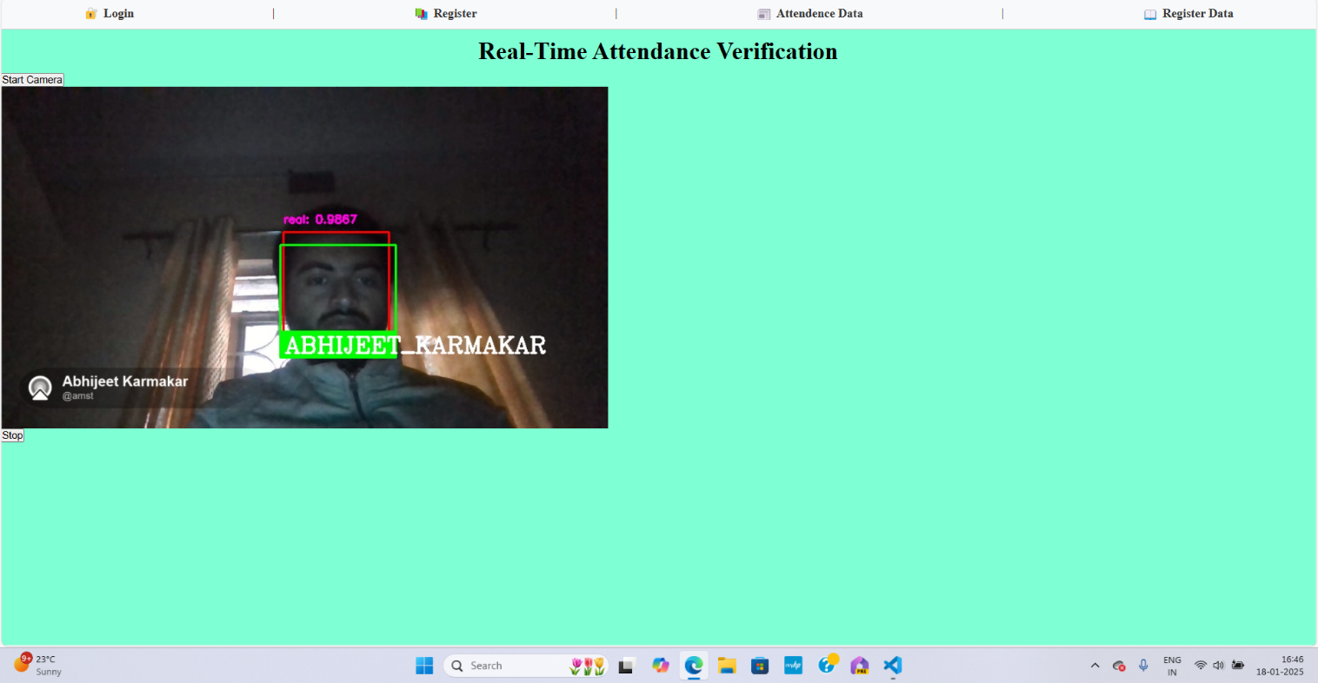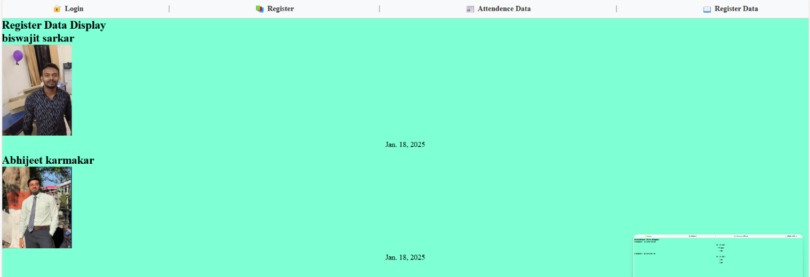

# Coding

Gathering Images Via Real and Fake videos .

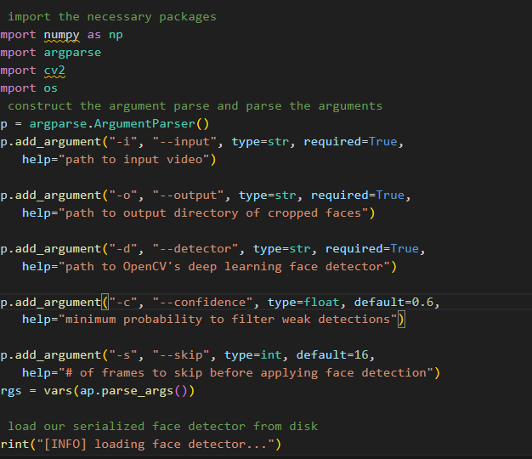

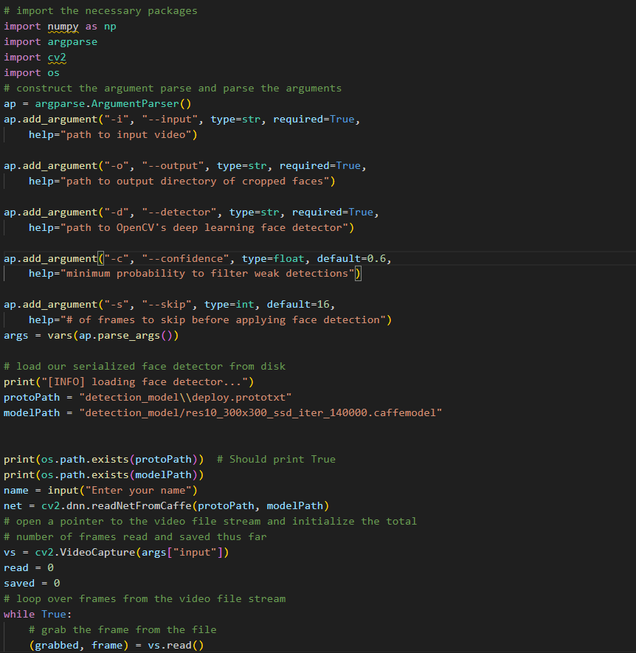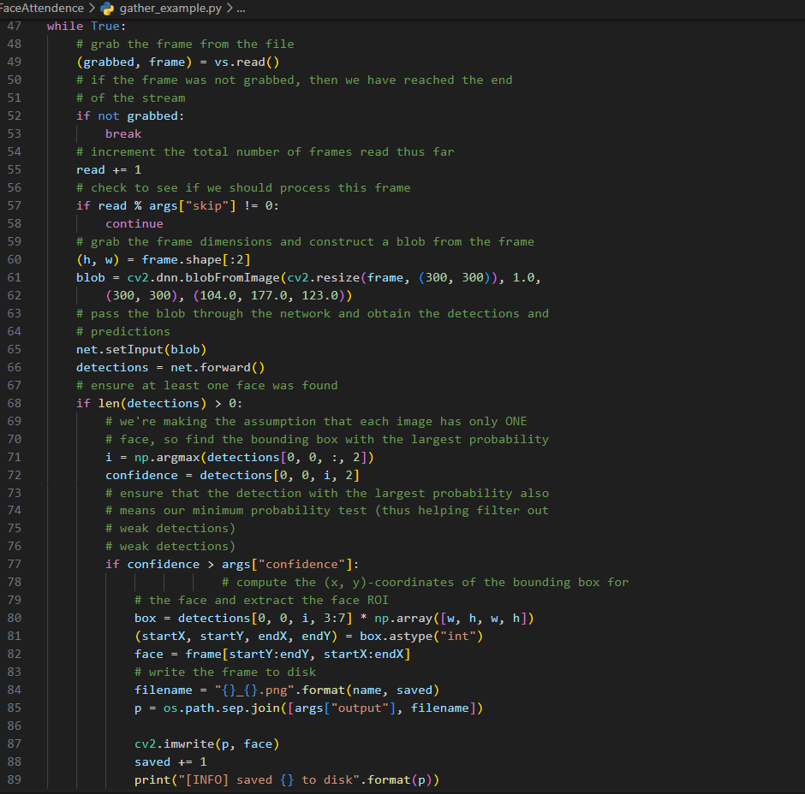

# Complete Project Coding is not required. Include important modules' codes only.

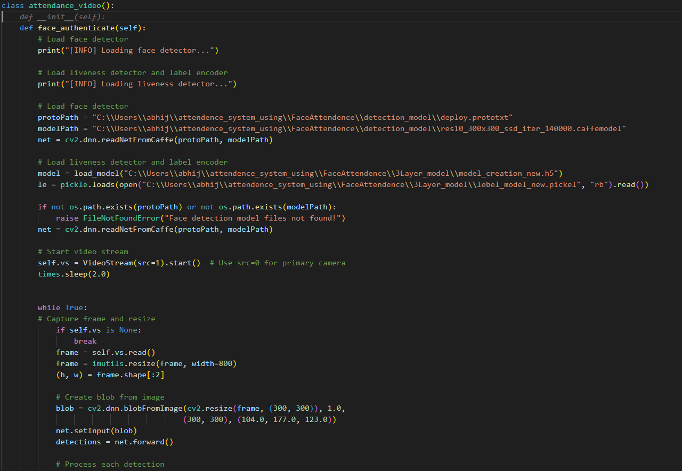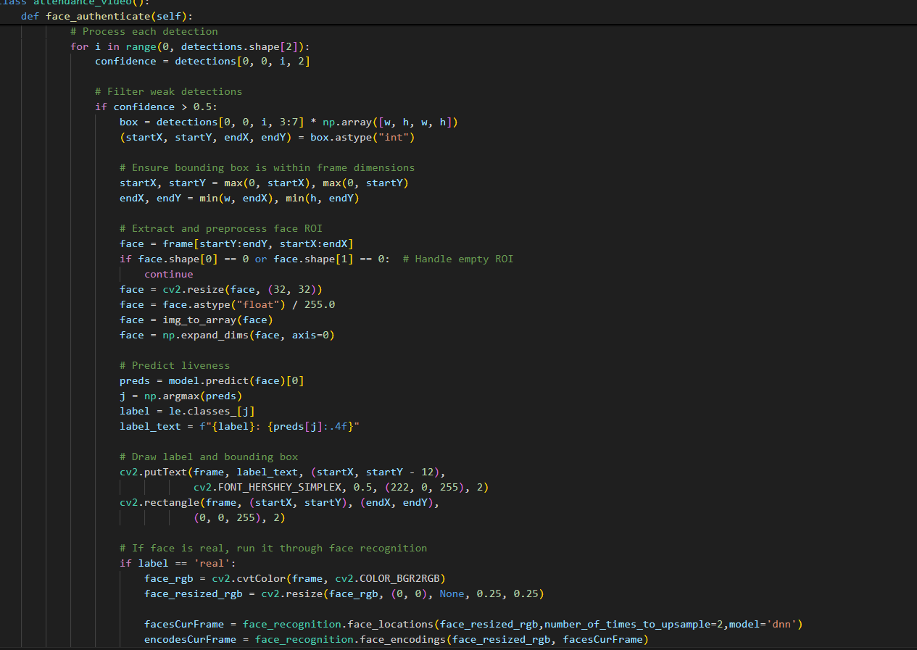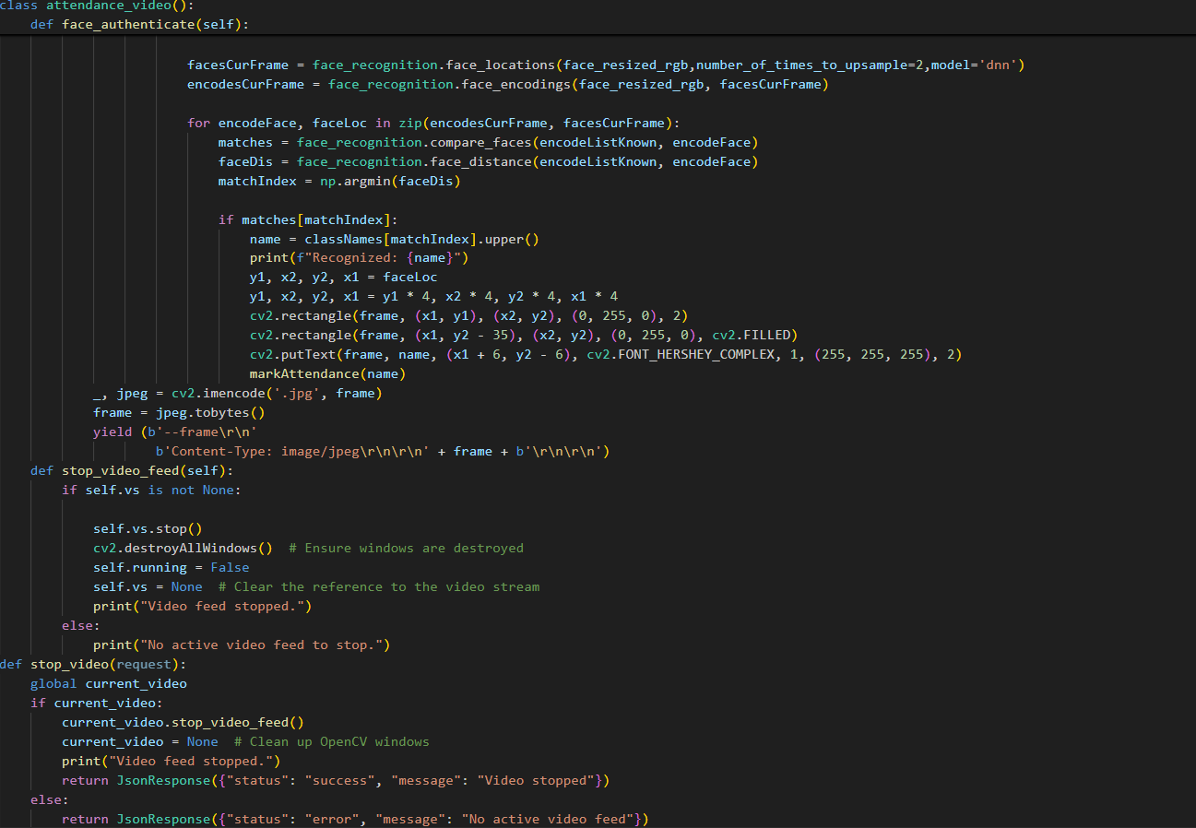

**Comments and Description**

This code is using camera access and stop the camera access after detecting the faces and storing int the database .

**Standardization of the coding /Code Efficiency**

This works faster than the normal running code because Django framework is usually faster than the other code frameworks and works faster even without GPU integration.

**Error handling**

We use error handling in all over the code for each and every occurring situation even if error occur it stops working.

**Parameters calling/passing**

Uses real time gzip Django functions for sending real time detection in this HTML pages for smooth and efficient access.

**Validation checks**

Checking the database storing check and proper recognition check using some parameters.

# Testing

# A. TESTING TECHNIQUES USED

User Acceptance Testing (UAT) and Unit testing.

# B. TESTING STRATEGIES

# White Box Testing

Input testing whether all the user input data is properly stores and matches the criteria and checking video starts and stop checking and antispoofing and facedetection checking .

# Debugging and Code improvement

Real-time debugging and finding error in each module so code works perfectly as the requirements. Code improvement day by day to achieve robust system.

**System Security measures (Implementation of security for the project developed)**

# Database/data security

Data Storing security checking for intruder access and proper system starts login checking and proper attendance storing into the mysql3 database with registration data name and photo location.

# Creation of User profiles and access rights

User profiles for admin access to the database and the website access for logging data and start logging system.

# Cost Estimation of the Project

It takes some cost for hosting the website into the cloud for faster access or we can use some hardware for faster working with using IOT edge devices like Rasberry pi for this project.

# Reports (sample layouts should be placed) PERT Chart, Gantt chart

# Conclusion and Recommendations

The Face Attendance System with Anti-Spoofing and Multiple Face Recognition will help to build a scalable application for day to day attendance process no need to worry about the storing the data and it can be access in various platforms using web interaction .

Our aspect is to build a strong and powerful attendance system to daily life institute and industries it can usually detects the faces with some sort of distance and stores the person present in the database. Our future goal is to add some features like a single application can hold different types of worker's attendance and refine a ideas into this suitable project building a real-life daily basis attendance using IoT technology. (i.e. Future scope and further enhancement of the project).

# Referencing and Appendices

The project report must be considered as a very standard report, and therefore, it should follow all rules, guidelines and protocols of gathering and presenting information, and implementing that and drawing conclusions out of it.

All these activities require appropriate and authenticsources of information and that particular information must be referenced or cited according to the copyrightsand other guidelines. Therefore, to make the report original, it should be free from plagiarism and must follow standard citations and guidelines of citations to represent the reference names.

The appendices of a project report should be written in Times New Roman format of font size 10, and it should contain the information which is appropriate and added to the main text like [Reference No].

**Reference:** All the references should be arranged alphabetically or serially as the case may be for quoting in text.

For Journals:

Kerr, G.T. : Chemistry of Crystalline Aluminositicate; The J. Phy. Chem., April 1968, vol.73, no.3 pp1385-1386.

Garside, J. et-al; Industrial crystallization from solution; Chem..Engg.Sci., 1985, vol. 40, no.2, pp. 3-26.

For books:

MeCabe and Smith; Unit Operations in Chemical Engg., 4th ed., TMH, pp.812-814.

**Note:**

Creating a System using Django and Python codes will enable to building fast and responsive website it needs reliable maintenance and proper error observation and full proper storage maintenance.